January 14, 2021 Meeting Minutes
North State Barrel Racing Association held a meeting Thursday January 14th at Humble Joes in Anderson. Those in attendance included:
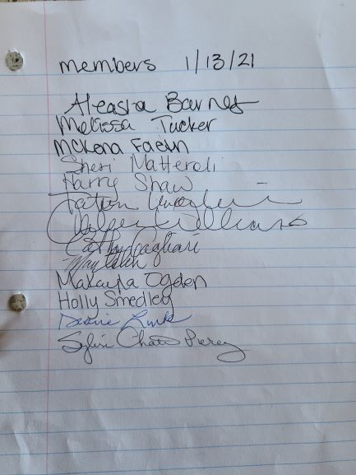

Meeting started at 6:34 PM.
Holly Smedley read the minutes from December 17th meeting. Melissa motion and Sheri second.
Treasurers report was read by Sylvie. Sheri motioned and Mckenna second report.
Diane stated we have 210 members.
Old Business
Awards committee: Cathey Vallerga and Susie Gunter.
There was discussion regarding a missing rule about limited entries. This rule will be incorporated back into the rule book. May have been deleted by mistake back in 2016.
There was a discussion regarding creating a rule back in December. The BOD will expand rule 2.2 and post on the web site for members to vote on. Sheri motioned and Sylvie second. Sylvie motioned to add a 72-hour contact rule and Sheri second. Approved unanimously by members.
Current Rule 2.2:
It is mandatory that every member/owner/arena operator/rider or individual observe an attitude of professionalism and good sportsmanship with courtesy to other participants and arena operators.

Expanded Rule 2.2
It is mandatory that every member/owner/arena operator/producer/rider or individual observe an attitude of professionalism and good sportsmanship with courtesy to other participants and producers/arena operators. If an NSBRA member is found not conducting themselves accordingly, then the producer/arena operator must contact an NSBRA BOD within 72 hours of the event. The BODs will take the following action:
2.2.1 First Offense: BODs will send the member a letter of warning.
2.2.2 Second Offense: BODs will send the member a letter and charge a fine of $250. The fine must be paid before earning any future points/credits. No entry into Finals until fine is paid.
2.2.3 Third Offense: BODs will send the member a letter of suspension for the remainder of the competition year, including the Finals.

We’re still on for the Budlight 3000. $1,000 and buckles will be awarded.
New Business
Sheri requested an additional insurance certificate for Rickey Qtr. Horses arena. Melissa will follow up.
Kaillee will add a race series on calendar.
McKenna will do a fundraising race.
Aleasha will have a Jr. Roundup race.
Sylvie motioned to adjourn meeting at 7:44 pm. Sheri second.

